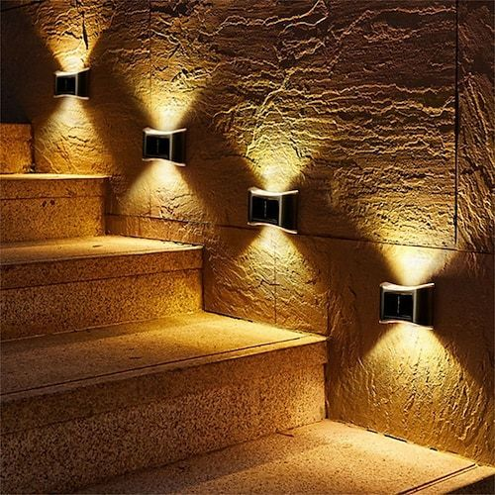

**Product Name:** Solar Led

**Price: 4pcs RS 5,999/**

# Description: Waterproof Solar Wall lights.



Bright World